

1. **Look at the picture and choose Yes or No. Look at the example:**

**Example:**

1. On Tuesday, Sophie has eggs and juice for breakfast. Yes No
2. On Thursday, Tommy has cereal for breakfast. Yes No
3. On Friday, Sophie has fruit and juice for breakfast. Yes No
4. On Saturday, Tommy has toast and cheese for breakfast. Yes No
5. On Monday, Tommy has juice and bread and Sophie has Yes No

cheese and cereal for breakfast.

1. On Wednesday, Sophie has milk and bread and Tommy Yes No

has coffee and eggs for breakfast.

**New Horizon School Aguazul-Casanare**

**Final Test**

**Name**: _____________________________________________________________

**Date**: ______________________________ **Grade**:Second

|  |  |  |  |  |  |  |
| --- | --- | --- | --- | --- | --- | --- |
|  |  |  |  |  |  |  |
|  |  |  |  |  |  |  |

Sunday

Saturday

Friday

Thursday

Wednesday

Tuesday

Monday

Sophie

Tommy



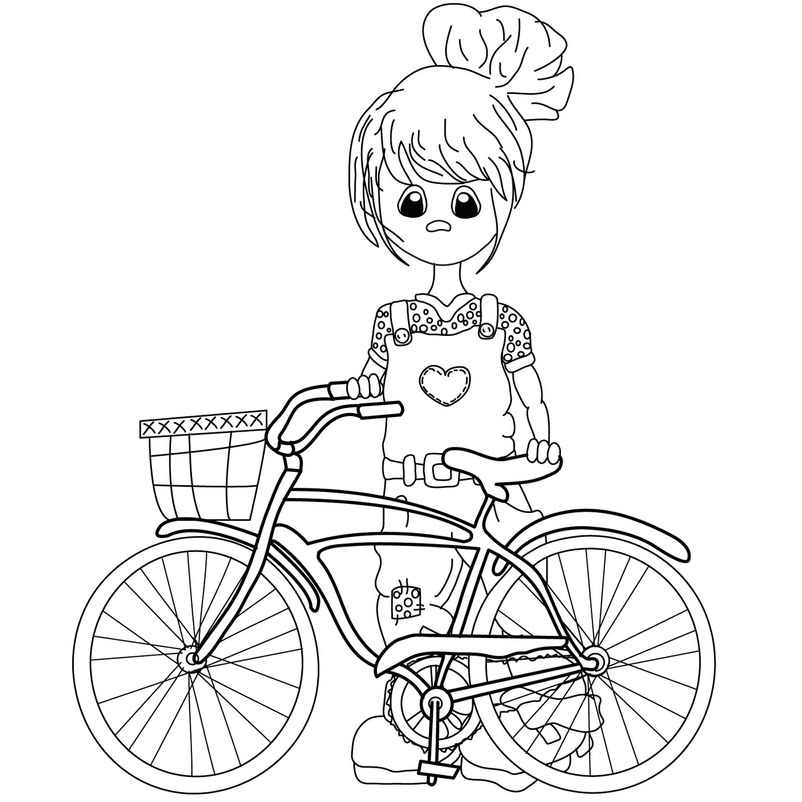

**Wordbank**

**2. Read and complete the text as in the example:**

Hello! I’m Dennis. Today I’m visiting an eco-park with my friends. There are many interesting animals. Look, there is a chimpanzee. It can 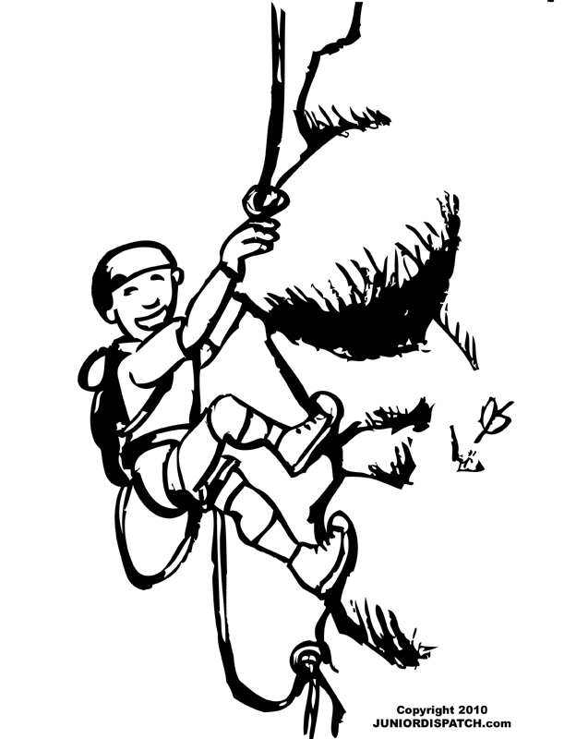____________climb___________ trees, but it can’t 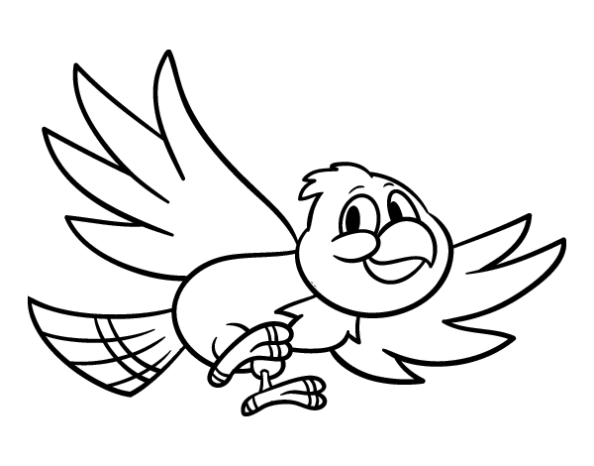_______________________. There are also big animals everywhere. That is a zebra: it can _______________________ really fast. That is a lion. It is very strong and it can 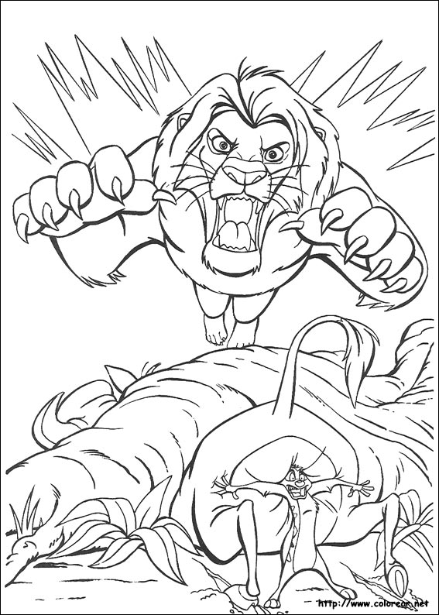_______________________. This is a kangaroo. It can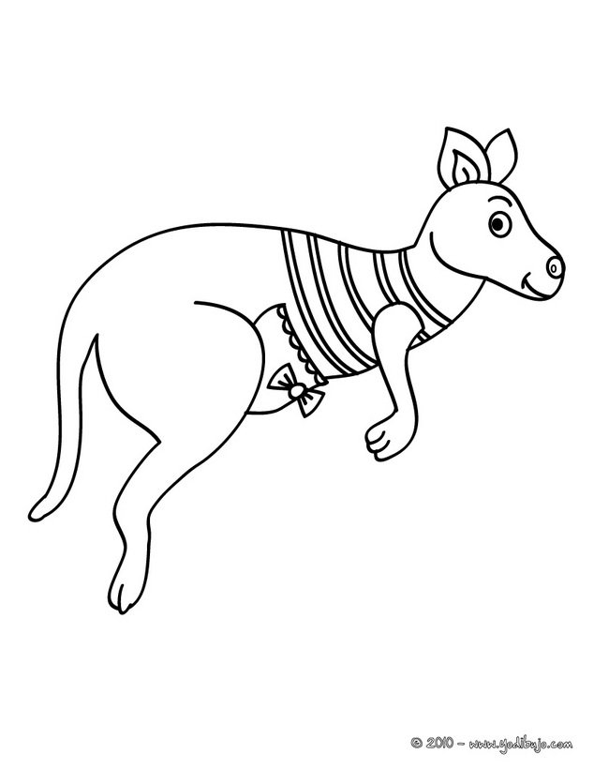 _______________________ really high, but it can’t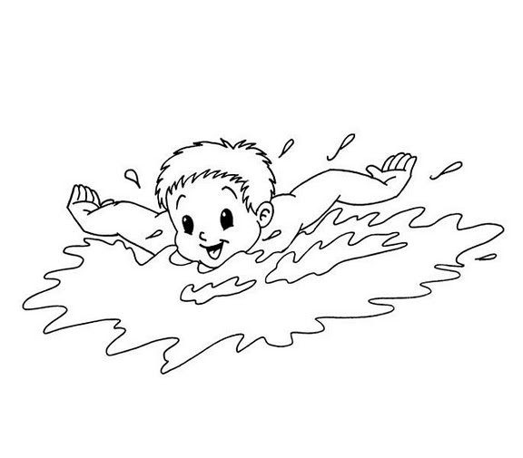 _______________________.

Hop

Climb

Swim

Hunt

Run

Fly

**3. Write the name for each food.**

|  |  |  |  |
| --- | --- | --- | --- |
|  |  |  |  |
| **a)** | **b)** | **c)** | **d)** |
|  |  |  |  |
| **e)** | **f)** | **g)** | **h)** |
|  |  |  |  |
| **i)** | **j)** | **k)** | **l)** |
|  |  |  |  |
| **m)** | **n)** | **o)** | **p)** |

a)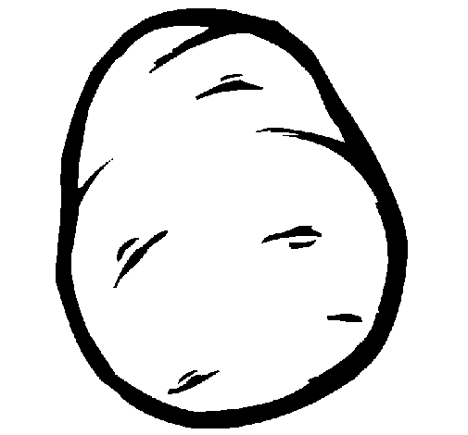 b)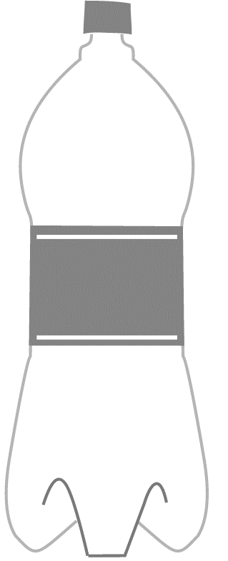 c)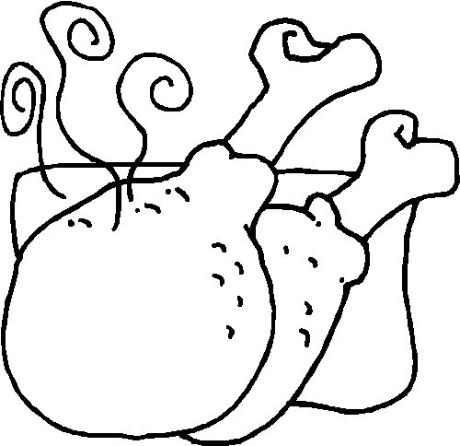 d) 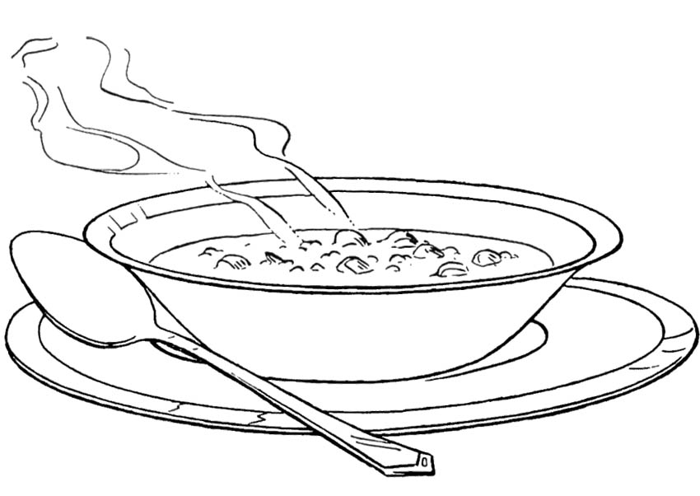 e)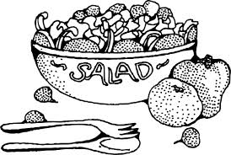 f)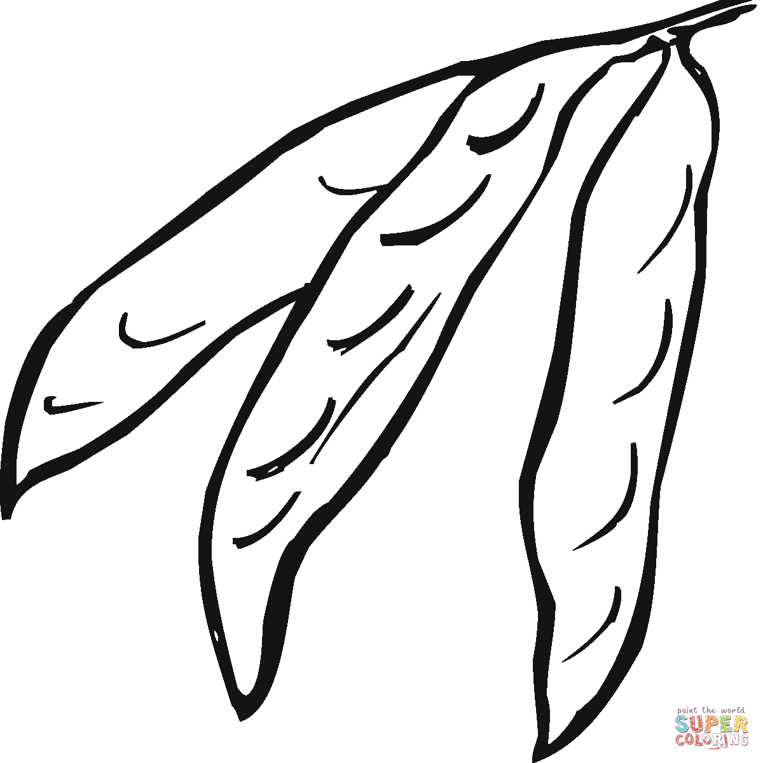g)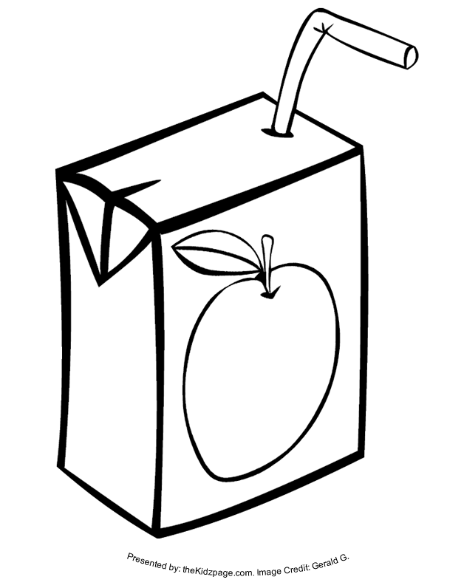 h)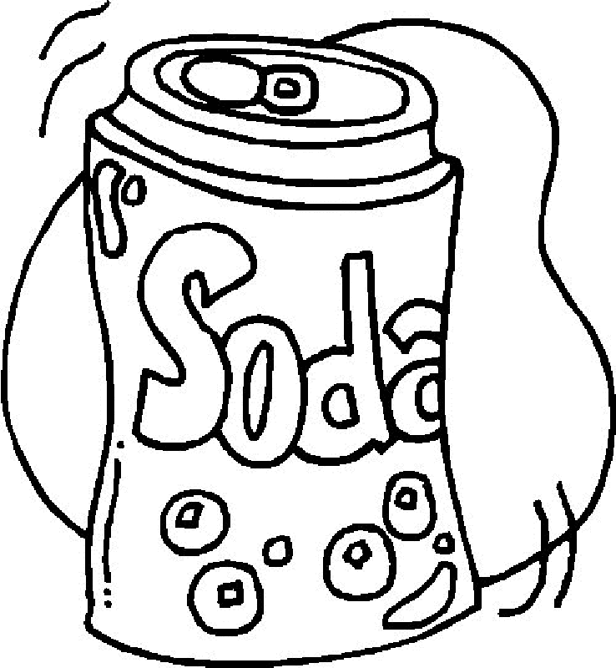

Andrew



**4. Write what each person likes or not. Look at the examples.**

**Example:**

1. I **like to eat potatoes.**

Me gusta comer papas.

1. **I like to drink water.**

**Me gusta beber agua.**

1. **_________________________________________________________________________.**

**_________________________________________________________________________.**

1. **_________________________________________________________________________.**

**_________________________________________________________________________.**

1. **_________________________________________________________________________.**

**_________________________________________________________________________.**

1. **_________________________________________________________________________.**

**_________________________________________________________________________.**

1. **_________________________________________________________________________.**

**_________________________________________________________________________.**

1. **_________________________________________________________________________. _________________________________________________________________________.**

a)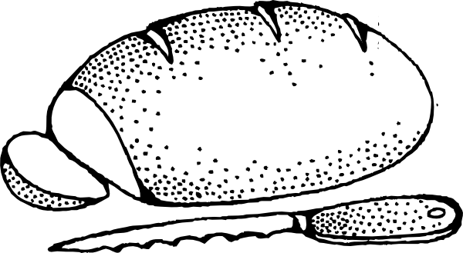 b)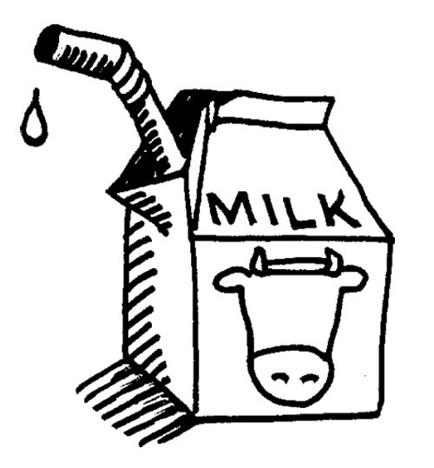 c)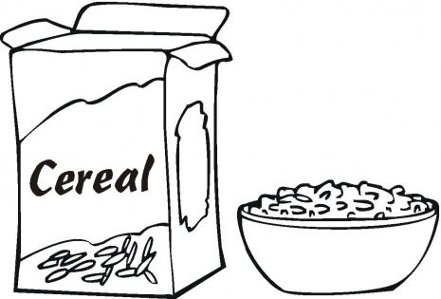 d) 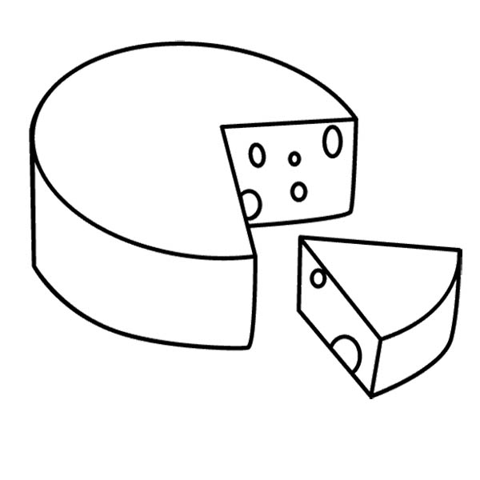 e)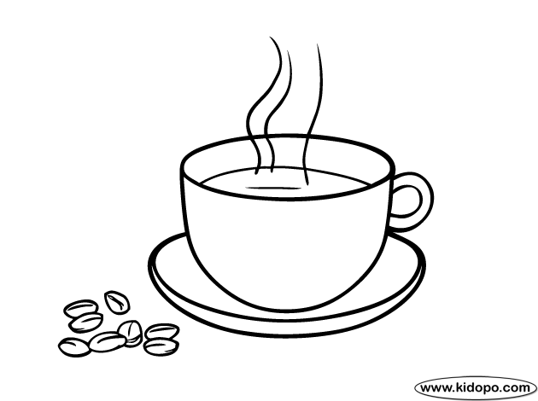 f)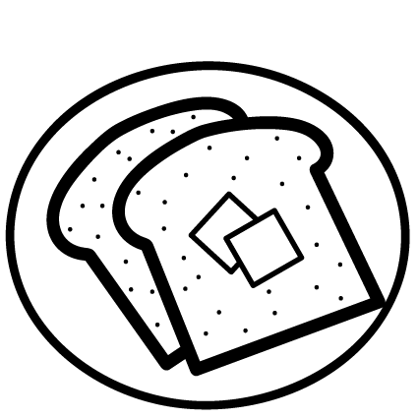g)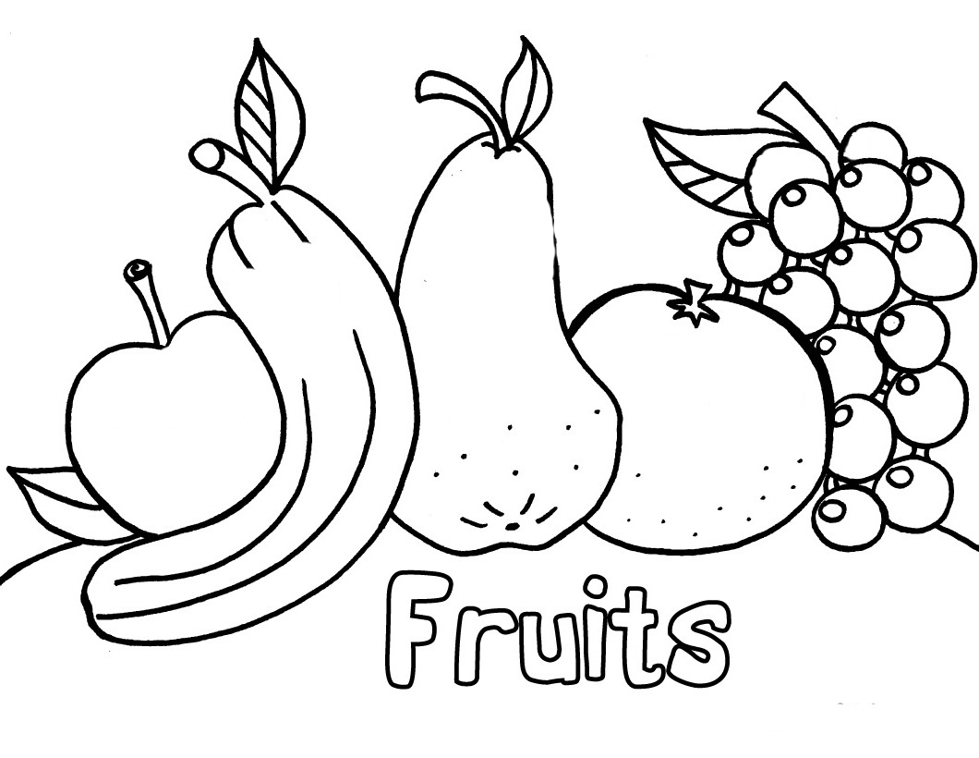 h) i)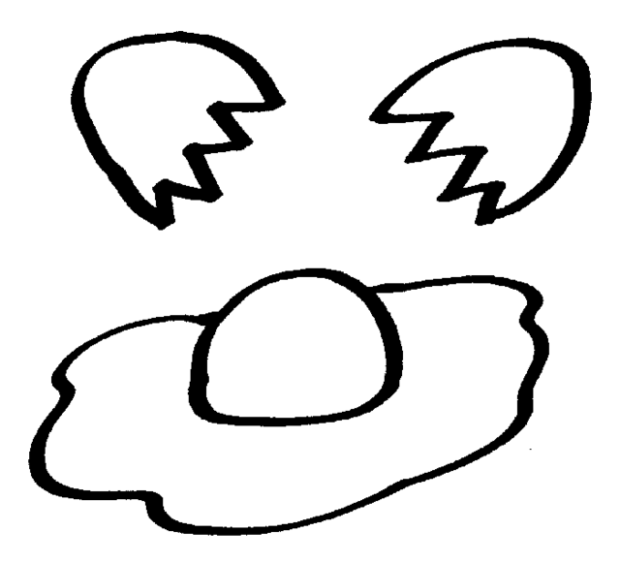



Gisel

**5. Write what each person likes or not. Look at the examples.**

**Example:**

1. I **don’t like to eat bread.**

No me gusta comer pan.

1. **I don’t like to drink milk.**

**No me gusta beber leche.**

1. **_________________________________________________________________________.**

**_________________________________________________________________________.**

1. **_________________________________________________________________________.**

**_________________________________________________________________________.**

1. **_________________________________________________________________________.**

**_________________________________________________________________________.**

1. **_________________________________________________________________________.**

**_________________________________________________________________________.**

1. **_________________________________________________________________________.**

**_________________________________________________________________________.**

1. **_________________________________________________________________________. _________________________________________________________________________.**