

1. **Cut, organize the cards with the names, paste and color into the square.**

**New Horizon School Aguazul-Casanare**

**Final Test**

**Name**: _____________________________________________________________

**Date**: ______________________________ **Grade**: Transition

Bedroom

Bathroom

Kitchen

Living room

Bedroom

House

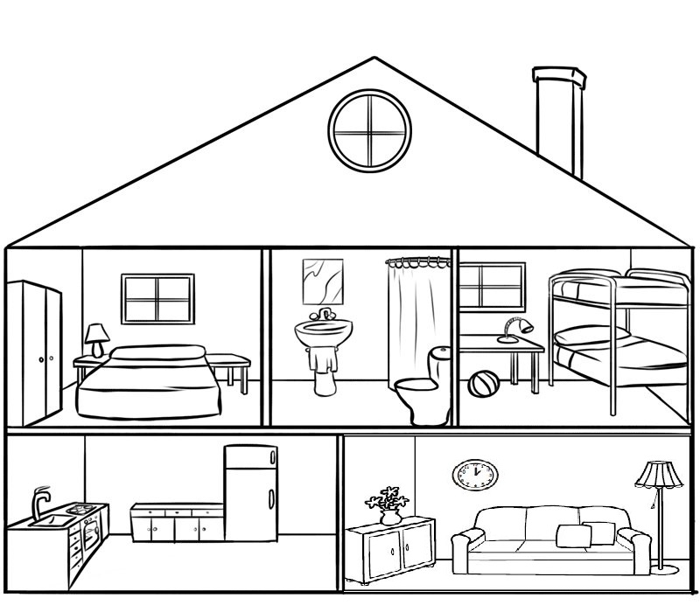





1. Cpu e. Keyboard
2. Screen f. Speakers
3. Printer
4. Mouse

**2. Write the parts of the computer under each picture.**

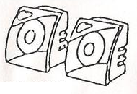 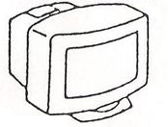 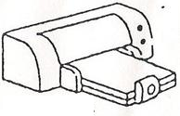

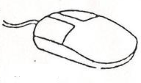 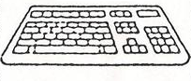 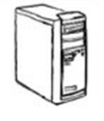

**3. Find the words in the wordsearch.**

