

1. **Write the name for those toys.**

|  |  |  |  |
| --- | --- | --- | --- |
|  |  |  |  |
|  |  |  |  |
|  |  |  |  |
|  |  |  |  |

1. **Write the action for each picture.**

|  |  |  |  |
| --- | --- | --- | --- |
|  |  |  |  |
|  |  |  |  |

**New Horizon School Aguazul-Casanare**

**Final Test**

**Name**: _____________________________________________________________

**Date**: ______________________________ **Grade**: First

**3. Circle the representative word for each image.**

|  |  |  |  |
| --- | --- | --- | --- |
|  |  |  |  |
| 1. **Snake** 2. **Tiger** 3. **Umbrella** | 1. **Tiger** 2. **Snake** 3. **Umbrella** | 1. **Umbrella** 2. **Vase** 3. **Tiger** | 1. **Vase** 2. **Snake** 3. **Tiger** |
|  |  |  |  |
| 1. **Water** 2. **Snake** 3. **Tiger** | 1. **X-ray** 2. **Yo-yo** 3. **Zebra** | 1. **Yo-yo** 2. **Snake** 3. **Tiger** | 1. **Zebra** 2. **Snake** 3. **Tiger** |

**4. Read and complete the text as in the example.**

Fly

Play

Play

Fly

Jump

Ride

Word Bank

Hi! My name is Gisel and I love to have fun on weekends! For example,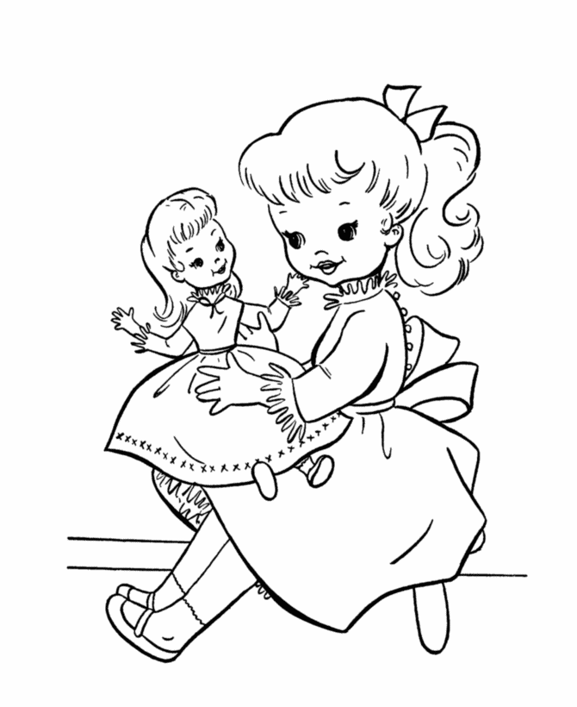 I __play__ with my dolls and 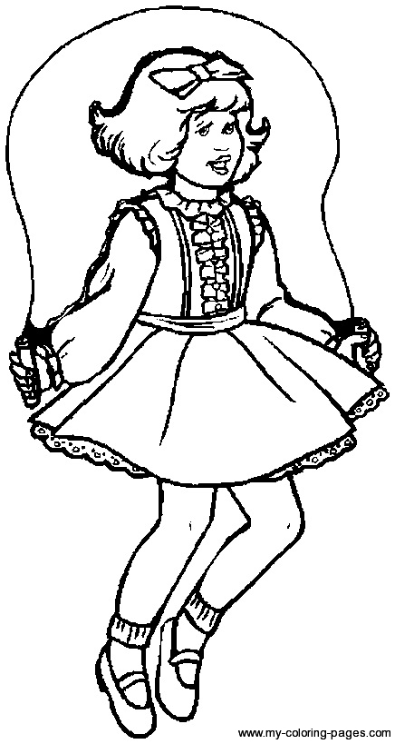 ____________________ rope (it is good exercise!).

I also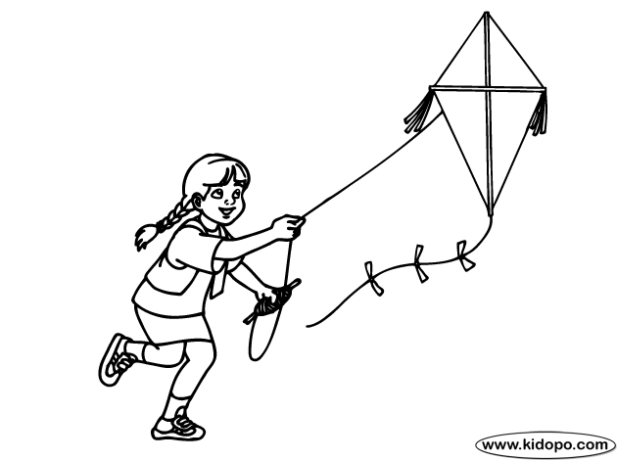 ____________________ my kite, 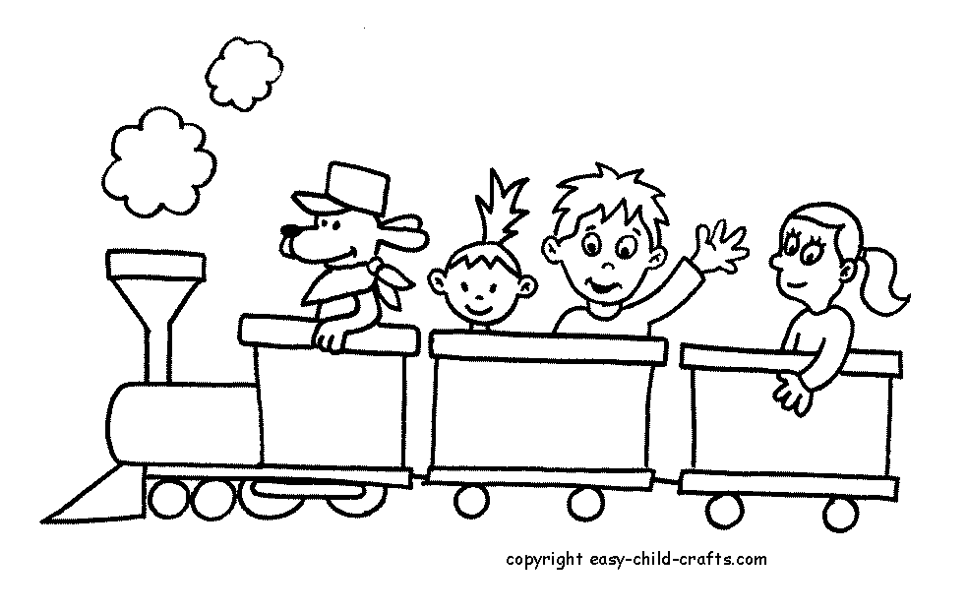____________________ with my trains and 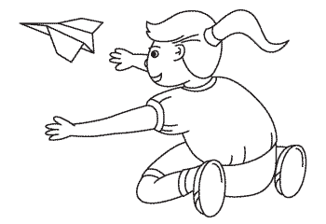____________________ small paper

planes with my brother, too! What about you? What are your favorite toys?

**5. According to each image write what she likes or not.**

Gisel

h)

g)

f)

e)

c)

d)

b)

a)

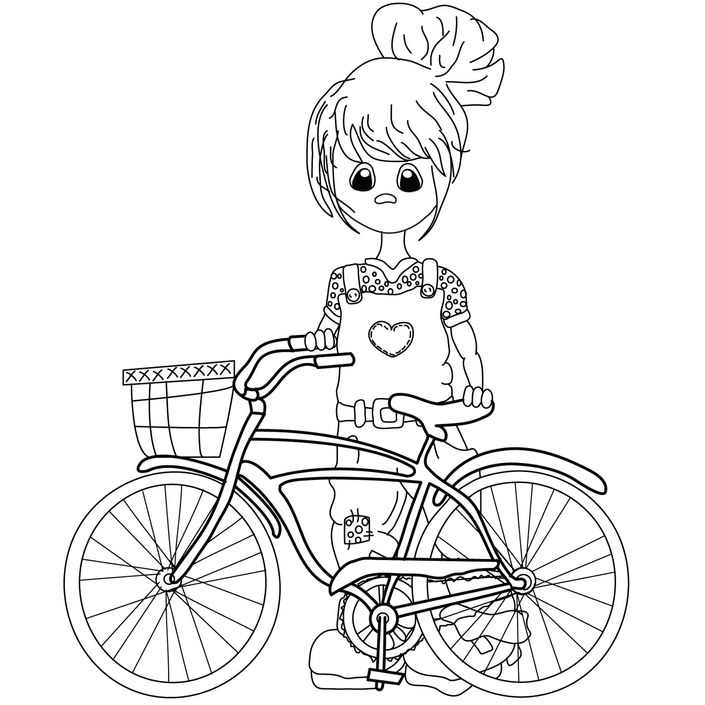

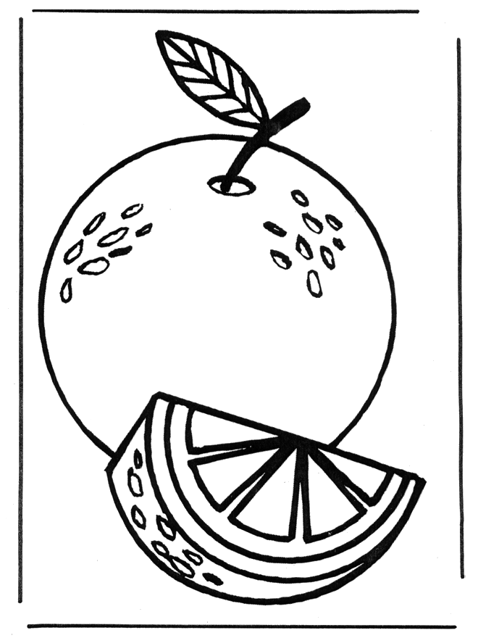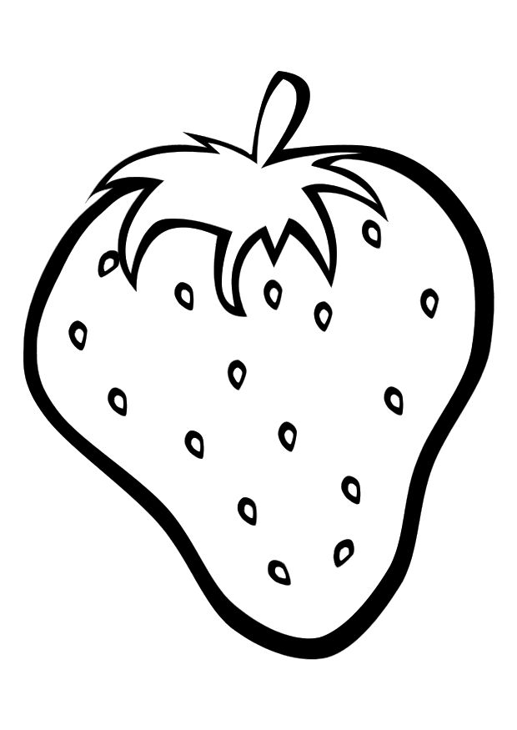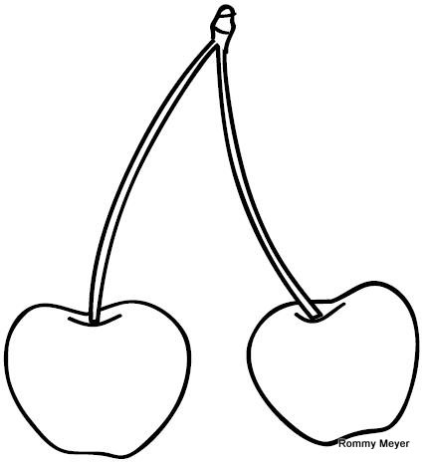 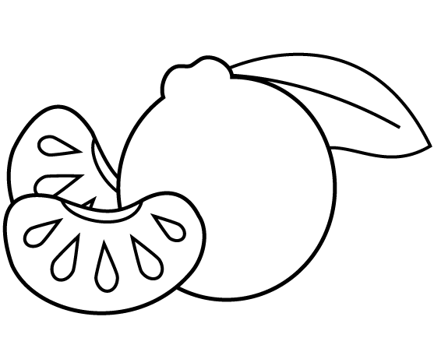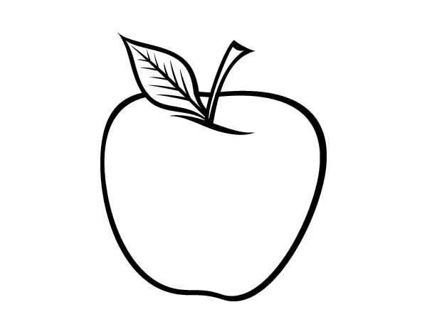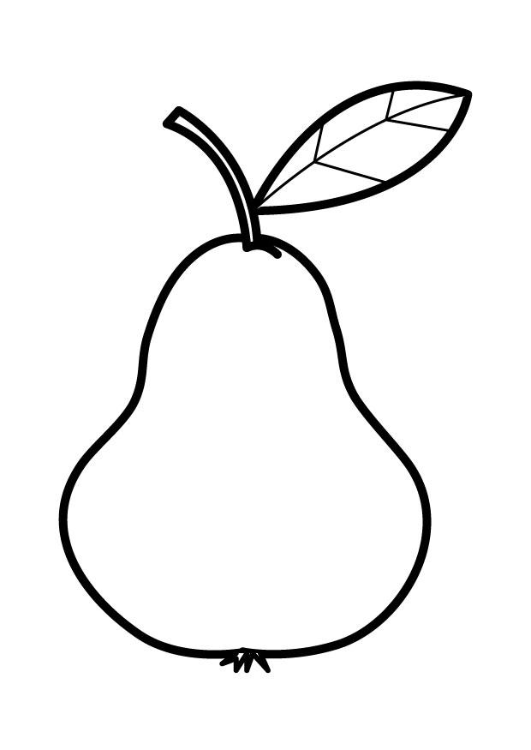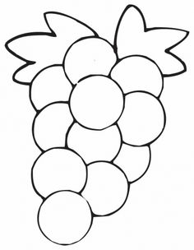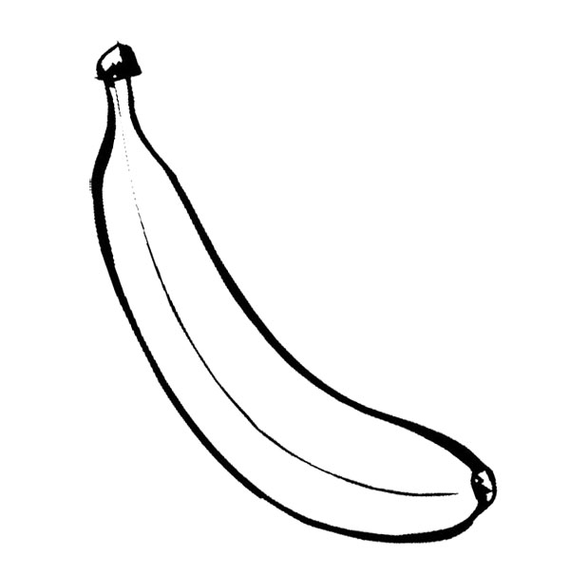

g)

c)

b)

a)

e)

f)

d)

Andrew

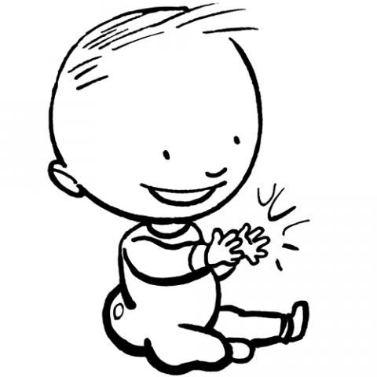

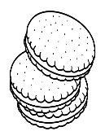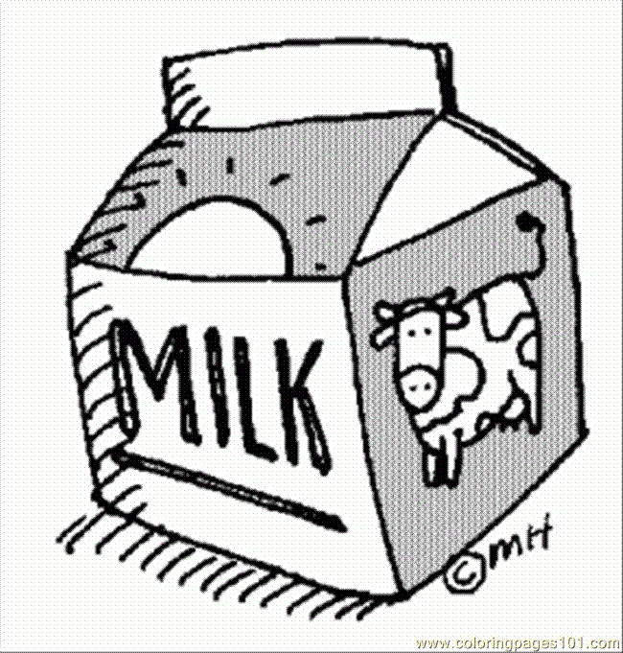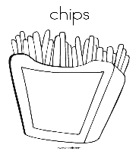  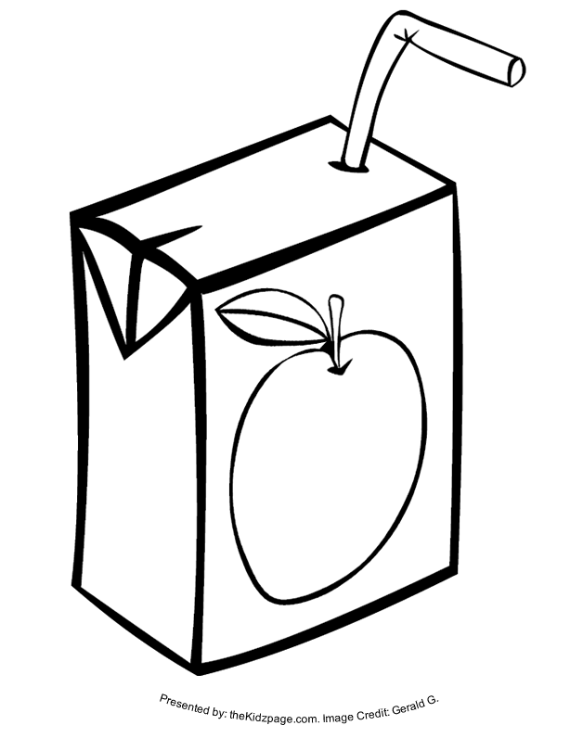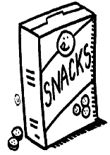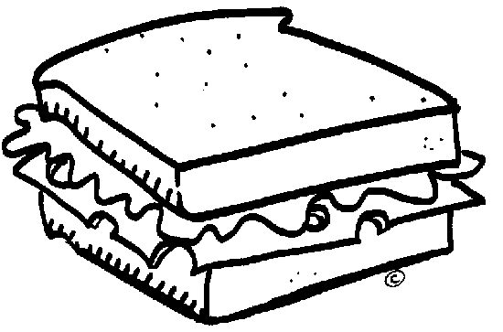

Example:

1. I like to eat orange.

Me gusta comer naranja.

1. _________________________________________________________________________.

_________________________________________________________________________.

1. _________________________________________________________________________.

_________________________________________________________________________.

1. _________________________________________________________________________.

_________________________________________________________________________.

1. _________________________________________________________________________.

_________________________________________________________________________.

1. _________________________________________________________________________.

_________________________________________________________________________.

1. _________________________________________________________________________.

_________________________________________________________________________.

1. _________________________________________________________________________.

_________________________________________________________________________.

**6. According to each image write what He likes or not.**

Example:

1. I don’t like to eat cookies.

No me gusta comer galletas.

1. I don’t like to drink milk.

No me gusta beber leche.

1. _________________________________________________________________________.

_________________________________________________________________________.

1. _________________________________________________________________________.

_________________________________________________________________________.

1. _________________________________________________________________________.

_________________________________________________________________________.

1. _________________________________________________________________________.

_________________________________________________________________________.

1. _________________________________________________________________________.

_________________________________________________________________________.

1. _________________________________________________________________________.

_________________________________________________________________________.